Security Incident Report / SITREP #2020-November-Report#2
Incident Detector’s Information
Date/Time of Report | 11/19/2020
First Name | Group 2
Last Name | Australia
OPDIV | IT Department
Title/Position | Cybersecurity Incident Response Professional
Work Email Address | Group2_Ausi@fvey.com
Contact Phone Numbers | Work: 555-123-4567 |  |  | Gov Mobile:  555-456-7890 |  | Government Pager: n/a |  | Other: n/a
Reported Incident Information
Initial Report Filed With (Name, Organization) | HR Manager / CISO
Start Date/Time | 11/19/2020
Incident Location | FVEY Global Economic Summit
Incident Point of Contact (if different than above) | Group 2 – Team Australia
Priority | Level 1
Possible Violation of ISO/IEC 27002:2013 | YES  12.0 – Operations Security  12.2 – Protection from Malware  12.5 – Control of Operational Software
Privacy Information - ISO 27000 (Country Privacy Act Law) | Was the incident a violation of ISO 27000? Yes  Did the target suffer an adverse effect? Yes  As a result, was the OPDIV the direct or proximate cause of the adverse effect? Direct  Was the violation intentional or willful? Intentional  Was the personally identifiable information used maliciously? Yes  INCLUDE PRIVACY IMPACT BELOW:  Privacy Act 1988 - Applies to all government and private sector entities and defines how personal and sensitive information can be collected, processed and/or transferred to other entities.
Incident Type | Reveton Ransomware Attack (bitcoin), Malware Attack, alter or destroy information
US-CERT Category | Denial of Service (DoS) – the attacker maliciously intended to interrupt authorized user access to the computer network.  Unauthorized Access – the attacker gained unauthorized access to the computer network to alter/destroy information and is now requesting ransom in the form of bitcoin  Malicious Code - Ransomware
CERT Submission Number, where it exists | CERT Australia – the national computer emergency response team provides advice and support or cyber threats and vulnerabilities to the owners and operators of Australia's critical infrastructure and other systems of national interest.
Description | Malware was used to launch a ransomware attack in an attempt to ransom crypto currency (bitcoin) from members of the FVEY nations.
Additional Support Action Requested | n/a
Method Detected | IDS and User Notification – The US reported that data exfiltration was detected in their intrusion detection system.
Number of Hosts Affected | 2 – Summit Attendees and HR Benefits Coordinator
OPDIV / Department Impact | National Security / Information Security
Information Sharing | Entities within Five Eyes (FVEY) Alliance can share incident data.
System | Australia’s Global Economic Summit Secure Comms Server
Status | Ongoing
Attacking Computer(s) Information
IP Address / Range |  | Host Name | Operating System |  | Ports Targeted |  | System Purpose
192.168.10.112 |  |  | HTTP |  | 1835 |  | Ransomware – store/transfer ransomware via attack script
23.23.99.139 |  |  | HTTP |  |  |  | Malicious Infrastructure
Victim's Computer(s) Information
IP Address / Range |  | Host Name | Operating System |  | Ports Targeted |  | System Purpose
192.68.10.201 |  |  | HTTP |  | 80 |  | HR Department – process Australia’s HR data Secure Network
84.200.69.80 |  |  | HTTP |  | 80 |  | Secure Network
Action Plan
Action Description | Team Australia will not comply with the bitcoin ransom demand of the attacker. The malware signature will be added to the IDS/IPS. Impacted files will be restored from a good backup. Antivirus software and firewalls will be installed along with scanning and filtering of email servers. Ensure that all systems and software are up to date with applicable patches. Using VirusTotal and AlienVault tools, we reviewed the hash from the indicator report (see below).  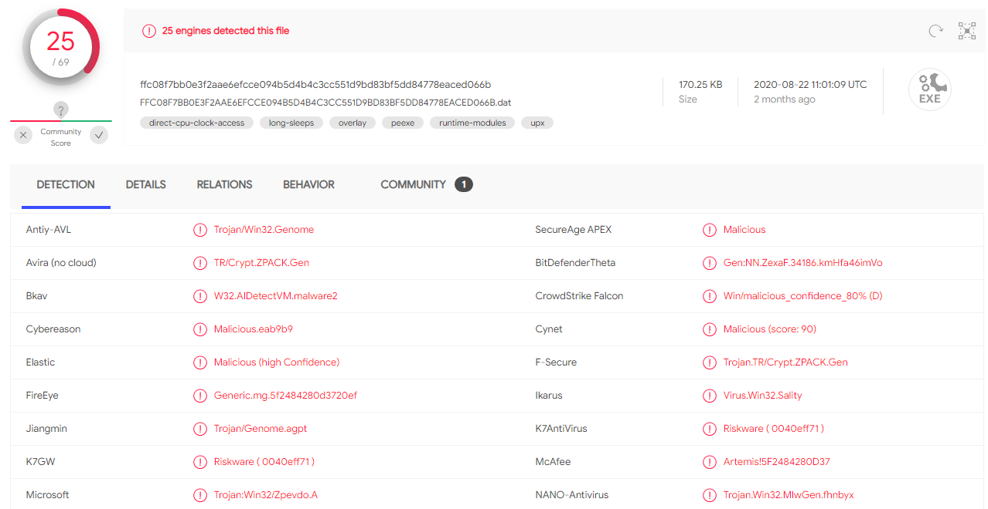  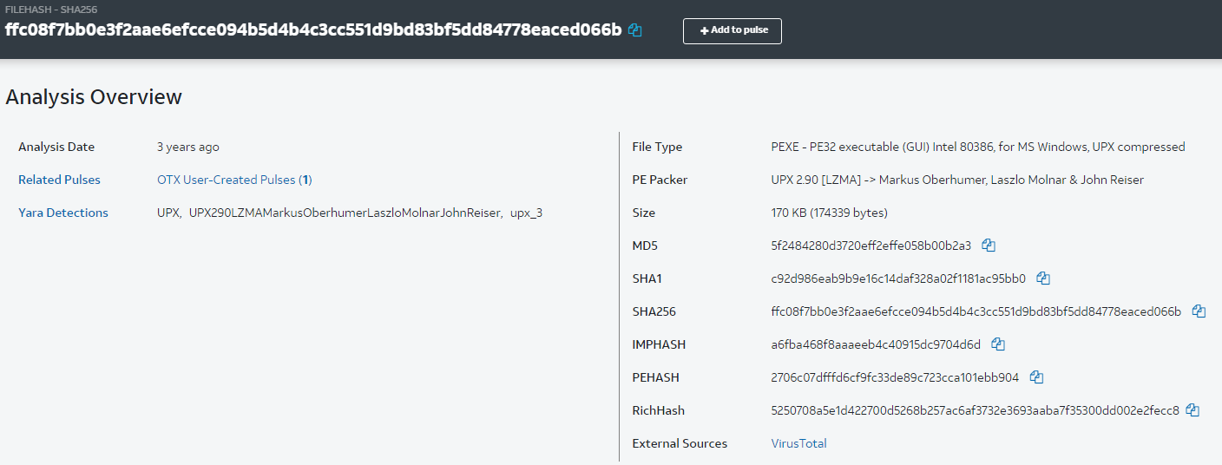
Requestor | CISO
Assignee | Group 2 – Team Australia – Cybersecurity Incident Response Professionals
Time Frame | 11/19/2020
Status | Ongoing
Conclusion / Summary
Entities Notified | CISO
Resolution | Cryptocurrency not paid. Server recovered from backups and malware isolated and blocked using SNORT.

References
ISO (2013). ISO/IEC 27002:2013 Information Technology – Security Techniques – Code of Practice for Information Security Controls. Retrieved from https://www.iso.org/obp/ui/#iso:std:iso-iec:27002:ed-2:v1:en
Kaspersky Lab (2020). What is Malicious Code? Retrieved from https://www.kaspersky.com/resource-center/definitions/malicious-code

