JetBlue Airways Corporation, 2015
www.jetblue.com, JBLU
Headquartered in Long Island City, New York, JetBlue is a passenger airline carrier company operating a fleet of 13 Airbus A321 aircrafts, 130 Airbus A320 aircrafts, and 60 EMBRAER 190 aircrafts. JetBlue serves 90 destinations in 27 states, the District of Columbia, Puerto Rico, the U.S. Virgin Islands, and 17 countries in the Caribbean and Latin America. JetBlue is sometimes called New York’s Hometown Airline, and is the leading carrier in Boston, Fort Lauderdale/Hollywood, Los Angeles (Long Beach), Orlando, and San Juan.

MyManagementLab®
For additional assurance of learning questions which prove you understand and are able to apply the strategic concepts in this case, go to the assignment section of your MyLab.
JetBlue reported a 1.5 percent decrease in yield per passenger per mile as the company’s average airfare decreased to $166.17 in 4Q 2014 from $168.94 in 4Q 2013. For 4Q 2014, JetBlue’s revenue passenger miles (or RPM) increased 8.5 percent to 9,392 million miles. Capacity, or available seat miles (or ASM), and load factor (or capacity utilization) drive RPM growth for an airline. For 4Q 2014, JetBlue’s capacity increased 7 percent to 11,436 million, and seat occupancy increased to 82.1 percent from 80.9 percent in 4Q 2013.
Lower fuel prices have helped airlines’ performance metrics, but JetBlue competes with many aggressive, growing rival companies, including Spirit Airlines, Southwest, American Airlines, Delta Air Lines, United Continental, and even rapidly growing Virgin America. On April 22, 2014, JetBlue’s pilots voted to unionize, for the first time since the airline was founded in 1999, with 71 percent of the airline’s pilots voting in favor of joining the Air Line Pilots Association (ALPA).
For Q2 2015, JetBlue’s number of revenue passengers grew by 8 percent year-over-year, indicating growing demand for the airline’s services. JetBlue’s traffic grew by 9.8 percent year-over-year for the first half of 2015. The airline improved its load factor, or aircraft utilization, by 1 percent to 85.6 percent for Q2 2015. JetBlue also increased its capacity in Q2 2015—measured by available seat miles (or ASM)—by 7.5 percent year-over-year. This was the second-highest capacity increase among the six major airlines. In 2Q 2015, JetBlue’s competitors notched the following capacity increases:
- Alaska Air Group (ALK): 10.7%
- Southwest Airlines (LUV): 7%
- Delta Air Lines (DAL): 6%
- United Continental (UAL): 2.3%
- American Airlines (AAL): 1.5%
JetBlue needs a clear strategic plan for the future.
Copyright by Fred David Books LLC. www.strategyclub.com (Written by Fred R. David)

History
Former Southwest Airlines employee, David Neeleman, incorporated “NewAir” in Delaware in August 1998 but later changed its name. JetBlue started by following Southwest’s approach of offering low-cost travel, with the exception that JetBlue would offer amenities, such as in-flight entertainment—for instance, a TV at every seat and Sirius satellite radio. Neeleman’s vision for JetBlue was “to bring humanity back to air travel.”
In September 1999, JetBlue was awarded 75 initial take off/landing slots at JFK International Airport in New York City. The airline started operations on February 11, 2000, with service to Buffalo and Ft. Lauderdale.
In 2012, for the eighth year in a row, JetBlue was ranked “Highest in Customer Satisfaction Among Low Cost Carriers in North America” by J. D. Power and Associates. In 2013, JetBlue introduced Mint, a premium cabin service on transcontinental flights. The service began in 2014, using the Airbus A321-200 aircraft ordered by JetBlue. These planes are outfitted with winglets, as well as “lie flat” seats and moveable partitions that can create small suites on the airplane. Called “Mint” by JetBlue, these planes are configured with 16 business-class seats and 143 economy seats, instead of an all-economy configuration of 190 seats.
On September 18, 2014, JetBlue’s CEO, Dave Barger, announced his resignation from the company effective February 16, 2015, following reports that investors and the board were unhappy with his performance. Mr. Barger was replaced on the board, and as CEO, by Robin Hayes.
In late July 2015, JetBlue reported Q2 operating income of $282 million, compared to $141 million in Q2 the prior year. The company’s 2015 Q2 net income was $152 million, compared to $61 million the prior year. JetBlue’s 2015 Q2 operating revenues were $1.6 billion. Its revenue passenger miles for Q2 increased 8.7 percent to 10.5 billion on a capacity increase of 7.5 percent, resulting in a Q2 load factor of 85.6 percent—an increase of 1.0 points year-over-year. The company’s yield per passenger mile in Q2 also increased 0.2 percent to 14.28 cents, while passenger revenue per available seat mile (PRASM) for Q2 of 2015 increased 1.4 percent year-over-year to 12.22 cents, and operating revenue per available seat mile (RASM) increased 0.4 percent year-over-year to 13.17 cents. Given all these increases, and with oil prices falling in August 2015, JetBlue seems to have a bright future.

Internal Issues

Vision/Mission
JetBlue has a combined vision/mission that reads: “JetBlue Airways exists to provide superior service in every aspect of our customers’ air travel experience.” The company also has a customer bill of rights on the corporate website.

Organizational Structure
JetBlue lists nine top executives on its corporate website. The company appears to operate using a functional design, as illustrated in Exhibit 1.

Exhibit 1
JetBlue’s Organizational Structure
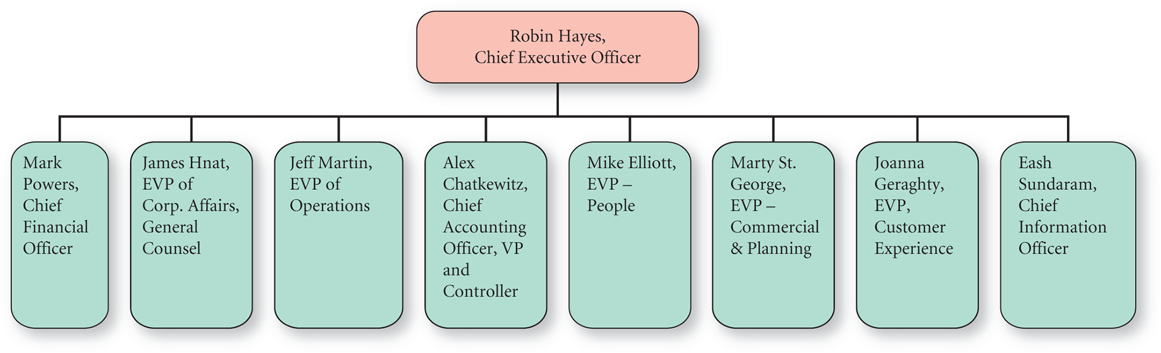
Source: Based on the company’s website.
Figure 1 Full Alternative Text

Segments
JetBlue has two reportable segments: (1) revenue from passengers filling seats and (2) revenue from ancillary amenity offerings. JetBlue’s ancillary amenity revenue, the higher-margin source, increased 3 percent to $25 per customer in 4Q 2014. The airline’s total ancillary revenue increased to $745 million in 2014, a year-over-year increase of 11 percent.
Adding to its ancillary revenue, JetBlue in 2015 began adding baggage fees. To increase the company’s passenger revenue, JetBlue in 2015 cut the leg-room in some of its planes. These changes come even though JetBlue has long been one of the most enviable brands around, winning travelers’ hearts with free snacks and other amenities rarely found on rival airlines. Partly because providing amenities was the founder’s initial vision for the company, a recent poll revealed that the percentage of people polled who say they are positive about the JetBlue brand fell almost 8 points to 56.2 from 63.8 percent (based on information at YouGov, a research firm that surveys consumers about brand perceptions).

Passenger Load
JetBlue’s revenue passenger miles increased by 14.3 percent year-over-year to 3,183 million in January 2015, compared to 2,785 million the prior year. The company’s revenue passengers increased by 13.4 percent as its number of departures rose to 25,107 in January 2015 from 21,986 in January 2014. JetBlue’s passenger revenue per available seat mile (or PRASM) for January 2015 increased by 3 percent. The company’s available seat miles increased by 15.5 percent that month, but its load factor decreased by 0.9 percent to 81.9 percent.
JetBlue’s traffic and capacity growth increased during January 2015 to record the highest growth among its peers. Alaska Air Group (ALK), for example, recorded the second-highest traffic and capacity growth of 7.9 percent and 10.4 percent, followed by Southwest Airlines’ (LUV) 8.6 percent and 10.2 percent, respectively. Following those positions are Delta Air Lines’ (DAL) 3.6 percent and 6.2 percent and United Continental Holdings’ (UAL) 1.1 percent and 1.4 percent. Only American Airlines (AAL) recorded negative traffic and capacity growth of –2.8 percent and –0.2 percent, respectively.

Capacity Utilization
JetBlue had 203 aircraft at the end of 2014, including 138 A320s, 60 E190s, and 13 A321s. The company expects to take delivery of an additional 12 A321s in 2015. JetBlue’s total capital expenditure for 2015 is planned to range from $810 million to $860 million. However, to increase its cash flow, JetBlue deferred 18 Airbus aircraft deliveries, which will be delivered about 2022–2023, instead of in 2016–2018.
JetBlue’s overall capacity increased about 12 percent in 1Q 2015 and is expected to increase about 8 percent for the full year 2015. A high 16 percent growth is expected in JetBlue’s transcontinental flights, which comprise 30 percent of the company’s total capacity. Another 30 percent of the capacity is expected to be deployed in the Caribbean and Latin America, with another 29 percent deployed in Florida.

Fuel
Aircraft fuel is JetBlue’s largest expense category, representing 36 percent of total operating expenses in 2014, compared to 38 percent in 2013. The company’s average price paid for fuel decreased 5 percent in 2014 to $2.99 per gallon, but the company consumed 35 million more gallons of aircraft fuel in 2014 compared to 2013. In 2014, JetBlue recorded fuel hedge losses of $30 million compared to $10 million in fuel hedge losses in 2013. However, fuel and taxes expenses were down 6.5 percent from Q3 to Q4 thanks to a 50 percent drop in oil prices over the last quarter of 2014.

Salaries, Wages, and Benefits
Salaries, wages, and benefits are JetBlue’s second-largest expense, representing 24 percent of total operating expenses in 2014, compared to 23 percent the prior year. During 2014, JetBlue’s number of employees increased 7 percent and the average tenure of crew members increased to 6.2 years, both of which contributed to a $159 million, or 14.1 percent, increase compared to 2013. JetBlue recently agreed to provide its pilots a 20 percent pay increase in their base rate over 3 years starting in 2014. See Exhibit 2.

Exhibit 2
Notable Expenses for JetBlue
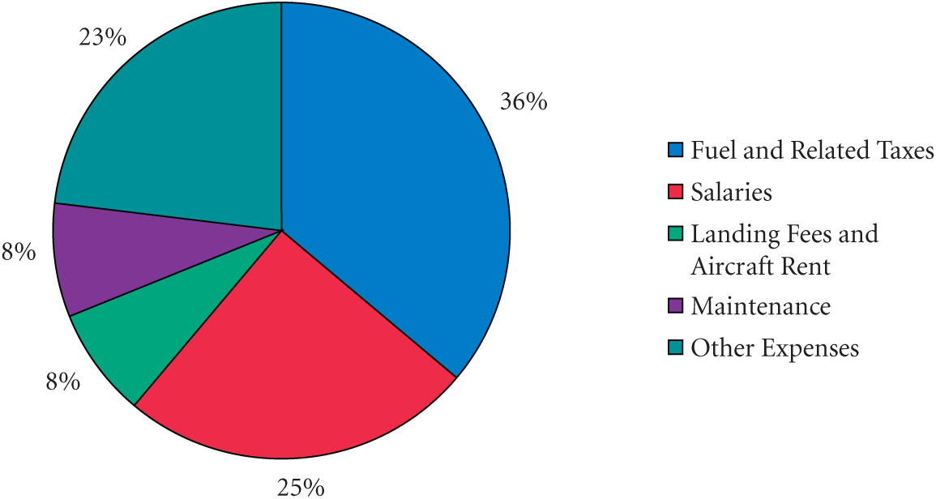
Source: A variety of sources.
Figure 2 Full Alternative Text

On-Time Performance
In 2014, JetBlue’s on-time performance improved by 4 percent year-over-year. Airlines measure their on-time performance by the number of flights arriving within 14 minutes of the scheduled arrival time, as well as the system’s arrival performance. JetBlue’s on-time departures in 2014 improved by 2.7 percent to 63.5 percent, and the system’s arrival performance improved by 2.5 percent to 77.1 percent. However, compared to rival airlines, JetBlue underperformed on these metrics. For example, Hawaiian Airlines had the highest 2014 on-time arrival rate of 92.3 percent, followed by Alaska Air’s 86.6, Delta’s 83, American’s 76.4, and United’s 76.1 percent, respectively, ranked slightly better than JetBlue.

Finance
JetBlue reported its highest net income ever in 2014—$401 million—an increase of $233 million over 2013, but the $401 million number includes an after-tax gain on the sale of a JetBlue subsidiary, LiveTV, of $169 million. LiveTV was JetBlue’s leading provider of inflight entertainment and connectivity systems for its planes. In 2014, JetBlue reported over $5.8 billion in operating revenue, led by rapid ancillary revenue growth. About 80 percent of JetBlue’s operations come from the northeastern corridor of the United States, which in 2014 and 2015 experienced very harsh winters, leading to 4,100 flight cancellations in 2014 alone, compared to about 2,100 cancellations in 2013.
JetBlue’s recent income statement and balance sheet are provided in Exhibits 3 and 4, respectively.

Exhibit 3
JetBlue’s Income Statement (in millions of USD)
Report Date | December 31, 2014 | December 31, 2013
Revenues | $5,817 | $5,441
Cost of revenue | 2,775 | 2,764
Gross profit | 3,042 | 2,677
Operating expenses | 2,285 | 2,250
EBIT | 757 | 427
Interest | 134 | 148
EBT | 623 | 279
Tax | 222 | 111
Net income | 401 | 168

Source: Based on company documents.
Table 3 Full Alternative Text

Exhibit 4
JetBlue’s Balance Sheet (in millions of USD)
Report Date | December 31, 2014 | December 31, 2013
Assets
Cash and equivalents | $341 | $225
Accounts receivable | 310 | 249
Inventories | 46 | 48
Other current assets | 503 | 534
Total current assets | 1,200 | 1,056
Property, plant & equipment | 6,072 | 5,656
Goodwill | — | —
Other assets | 567 | 638
Total assets | 7,839 | 7,350
Liabilities
Short-term debt | 265 | 469
Accounts payable | 698 | 580
Other current liabilities | 973 | 825
Total current liabilities | 1,936 | 1,874
Long-term debt | 1,968 | 2,116
Deferred liabilities | 832 | 605
Other liabilities | 574 | 621
Total liabilities | 5,310 | 5,216
Common stock | 4 | 3
Retained earnings | 1,002 | 601
Treasury stock | (125) | (43)
Paid in capital and other | 1,648 | 1,573
Total equity | 2,529 | 2,134
Total liabilities & equity | 7,839 | 7,350

Source: Based on company documents.

Competitors
For 2014, JetBlue and Delta Air Lines (DAL) reported the highest revenue growth of 6.9 percent, followed by Southwest Airline’s, 5.1 percent, Alaska Air Group’s (ALK) 4.1 percent, and United Continental Holdings’ 1.6 percent. Exhibit 5 provides some comparative metrics of JetBlue and other airlines. Notice that JetBlue’s revenue per employee is much less than United Continental, and its EPS is lowest among the sample air carriers.

Exhibit 5
JetBlue versus Rival Airlines on Key Metrics
 | JetBlue | American | Southwest | United Continental
$ Revenue | 6 B | 43 B | 19 B | 40 B
# Employees | 16 K | 115 K | 47 K | 85 K
$ Revenue per Employee | 375,000 | 374,000 | 404,000 | 470,000
$ Net Income | 400 M | 3 B | 1.2 B | 1.2 B
$ EPS | 1.20 | 3.95 | 1.66 | 2.95
$ Market Capitalization | 5.4 B | 33.5 B | 29 B | 25 B

Source: Based on a variety of sources.
Table 5 Full Alternative Text
The domestic airline business is highly competitive, led by Delta, American, and United Continental, with market shares ranging from 20 to 15 percent, respectively. Southwest’s U.S. market share is approximately 11 percent, with JetBlue and Spirit enjoying 3 and 1 percent market shares, respectively. The airline industry generates about $150 billion in annual revenues with the big 4 airlines (shown in Exhibit 5) accounting for over 50 percent of all revenue. In total, there are over 300 airline businesses in the United States.
It is fairly easy to begin an airline business; there are low barriers to entry because many airplanes are leased not owned by the carriers. However, ironically, it is often expensive to exit the industry, as airlines have long-term lease agreements in place. Airlines are notorious for low margins. The outlook moving forward is for the airline industry to grow about 2 percent annually. However, with the lower fuel costs, airlines may become more profitable as a group. In fact, American Airlines’ earnings per share was up 25 percent from Q3 2013 to Q3 2014, to $1.28, for an all-time record.

Spirit Airlines, Inc. (SAVE)
Headquartered in Miramar, Florida, Spirit is the nation’s deepest discount airline, offering customers numerous for-pay options, including bags, seat assignment, and refreshments. Spirit derives nearly 40 percent of its revenue from nonticket product purchases. To maximize efficiency, Spirit has all-Airbus, single-aisle planes, operating more than 325 daily flights to 57 destinations in the United States, Latin America, and the Caribbean. The nation’s “Ultra-Low Cost Carrier,” Spirit Airlines received a respected, independent endorsement recently in that Air Transport World named Spirit as the “Value Airline of the Year” at its 41st Annual Industry Achievement Awards ceremony.

Virgin America (VA)
Headquartered in Burlingame, California, Virgin America is a low-cost airline that provides air travel services in the United States and Mexico. Founded in 2004, Virgin America has a fleet of 53 Airbus single-aisle aircraft. The company performed exceedingly well in the final quarter of 2014, reporting better-than-expected earnings and revenues in the quarter. Virgin America is adding flights monthly, striving to keep costs low by flying a single aircraft type (Airbus A320 family) and outsourcing many activities such as baggage delivery, maintenance, and reservations.

Southwest Airlines (LUV)
Headquartered in Dallas, Texas, Southwest in 2015 began flying nonstop to eight new cities out of its main hub, Dallas Love Field, with 180 departures a day from Dallas Love Field to 50 destinations in the United States and near-international markets. At year-end 2014, Southwest operated 665 Boeing 737 aircraft and had 12 Boeing 717 aircraft. Southwest flies to 93 destinations in 40 states, the District of Columbia, and Puerto Rico, as well as Mexico, Jamaica, the Bahamas, Aruba, and the Dominican Republic.

United Continental Holding, Inc. (UAL)
Headquartered in Chicago, Illinois, United Airlines, the wholly owned subsidiary of United Continental Holdings, provides air transportation services all over the planet. UAL transports both people and cargo, using a fleet of 1,260 aircraft and having more than 84,000 full-time employees.

External Issues
According to SITA, a specialist in air transport communications and information technology solutions, the airline industry will soon see a major transformation in the way passengers interact with airlines. SITA says there are four major trends that will shape the future of global air travel in 2015 and beyond, as follows:
- Passengers will expect more personal service and airlines will deliver, primarily using smartphones and apps much more. For example, Alaska Airlines already has a travel app that alerts fliers to airfare deals from their hometowns and to cities where their friends live.
- Nearly every airline will offer mobile check-in—up from 50 percent today. Passengers will use 2-dimensional boarding passes or contactless technology on their phones, at different stages of their journey, such as at boarding gates to fast-track security zones.
- Customer services will become more mobile and social. Nearly every airline and airport will provide flight updates using smartphone apps. The industry is also exploring apps to improve the customer experience.
- Almost every airport and airline will offer business intelligence solutions aimed at improving customer service and satisfaction, often through personalized services. For example, a European airline, Vueling, researches customers via social media in order to better understand their behavior and then integrates this information into their own intelligence program to improve customer loyalty.

Market Segmentation
The airlines cater to a variety of customers but generally customers are categorized as coach, first class, business class, and freight. Coach passenger revenue tends to account for 80 percent of all revenue generated by air service companies. This revenue includes extra bag fees, food and drink, and all other fees associated with coach class passengers. Business class and first class passengers account for 10 and 5 percent of total revenues, respectively, with freight accounting for 3 percent of total industrywide revenues.

Airlines Hoarding Cash
Fearing economic downturns, airlines generally keep substantial cash on their balance represents. For example, Delta reported $5 billion in 2014 cash and short-term investments to 2013 revenues of $37 billion or 14 percent of revenue. American Airlines reported 2014 cash and equivalents of $8 billion, about 30 percent of revenue. JetBlue, for example, from 2012 to 2014 increased its cash position by 87 percent to $341 million. Delta increased its cash balance by 25 percent over the same time frame. Overall, the industry’s 2014 revenue passenger miles were up 2.5 percent, with passenger revenues rising 5 percent. Another area driving up cash balances and revenues for airlines are ancillary fees. Currently, 16 U.S. airlines charge baggage fees, totaling $3.4 billion in 2013. Reservation change fees generated another $2.8 billion in 2013 revenues for the airline industry. Generally met with great distaste and resistance among passengers, after being customary in the industry for a number of years now, most customers are now accustomed to the ancillary fees charged by airlines.

Airline Pollution Concerns
Airlines for years have fought the perception they are a major source of greenhouse gasses. Most airlines routinely list the ways in which they have reduced jet fuel usage and as a result greenhouse gases. Many of the ways listed, however, are often through higher fees on customers. Baggage fees, heavy bag surcharges, lack of free drinks and food, tighter seating arrangements, and smaller more fuel-efficient plans all have helped to reduce weight at the direct expense of customer comfort. So the jury remains out on the true motives of airlines in the battle against greenhouse gas emissions. Another interesting development in the industry is the use of biofuels instead of traditional jet fuel. Several firms, such as Continental and KLM Royal Dutch Airlines, have experimented with biofuels since 2009, but there does not appear to be industrywide acceptance or a hurry to switch in the foreseeable future.

Airline Taxes
Airlines pay high taxes. Delta, Spirit, JetBlue, and Southwest all paid taxes between 35 and 38.5 percent in 2014. However, American Airlines paid taxes of 11 percent and United Continental received a tax credit in 2014. President Obama recently proposed raising taxes on airlines to help reduce the federal deficit, improve immigration, improve airports, and reduce the wait-time for processing foreign visitors. Obama’s new airline tax plan would add between $2.50 and $9 per ticket one way. The cost of any new taxes is expected to be passed on to the consumer. Tax increases may not seem like much in absolute terms, but one analyst suggested a $300 domestic ticket’s taxes that are currently $61 would increase to $75, amounting to a staggering 23 percent tax increase. To compare what a 23 percent tax high relates to, the inflation rate in the United States during 2014 was around 1.5 percent.

Mergers Dominate the Industry
Two notable recent mergers include United and Continental and US Airways and American Airlines. While possibly attractive, at least in the short term for the airlines, the mergers came at the expense of substantial goodwill on the balance sheets. American, for example, reported no goodwill in 2012, yet after the merger with US Air, the new firm reported over $4 billion in goodwill. United Continental reports over $4 billion in goodwill on its balance sheet. The likely benefit for these firms is with reduced competition will come the ability to more easily raise airline ticket prices. In addition to higher prices facing airline passengers, airline CEOs are also altering their market-share–grabbing strategy by focusing on the most profitable area routes, reducing redundant routes, no longer serving certain routes, and being able to charge more for ancillary fees.

Future
For the full year 2015, JetBlue projects that its operating capacity will increase by approximately 8 percent over 2014, with the addition of 12 Airbus A321 aircraft to its operating fleet. The company projects that its cost per available seat mile, excluding fuel and profit sharing, will increase 1 percent over 2014.
The airline industry is intensely competitive, and is becoming more and more like a commodity. JetBlue is backing away from its amenities in order to compete and stay profitable, yet customers are expecting more personalized services and amenities. JetBlue needs a clear strategic plan. Help the company prepare this document.

